BAHRIA UNIVERSITY,
(Karachi Campus)
Department of Software Engineering
Assignment#03– Spring 2023

COURSE TITLE: OOP COURSE CODE: CSC-210
Class: BSE 2A/2B/2C Shift: Morning
Course Instructor: Engr. MAHAWISH Assignment Date: 12th May 2023
Max. Marks: 10 Points: CLO 3 Assignment Due: 29th May 2023
Q1: Apply OOP principles and design general admission registration form as shown below:
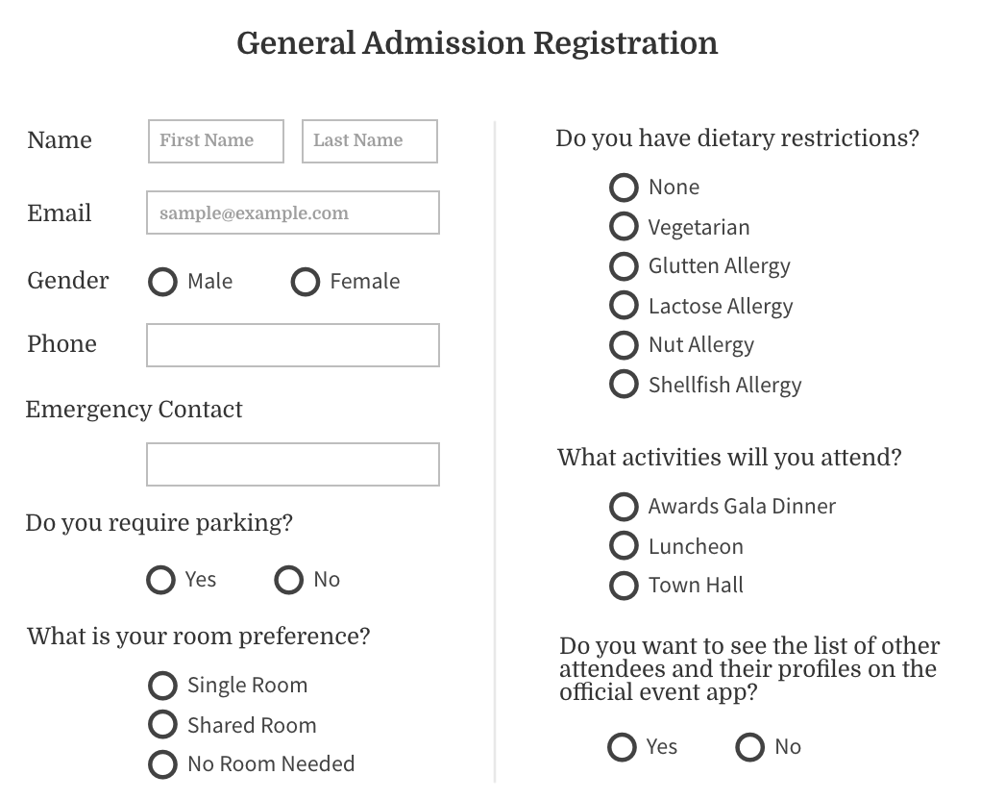
Submit
Clear

